1. **Setting Up Eclipse**

* We are currently using Luna Eclipse.
* Install Android SDK into your computer and Android Eclipse plugin.
* The zip package in Programming Ventoura contains all the source code.
* We are using git as our source(version) control system. You need an account in bitbucket (https://bitbucket.org/), not github.

1. **Importing all the source code into your eclipse**

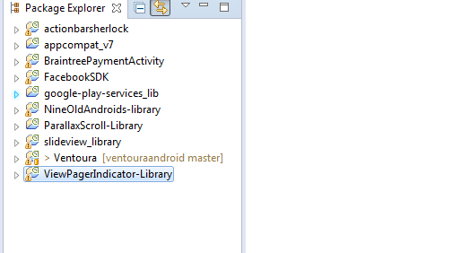

* The facebook SDK Version we are using is 3.15.0.
* The google-play-service_lib is located in your Android SDK. First make sure the google_play_service is installed:

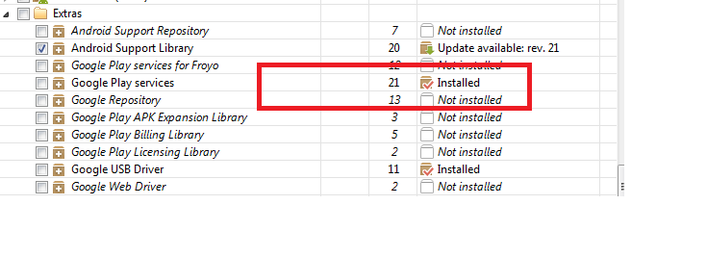

Then import Google_Play_Service project.

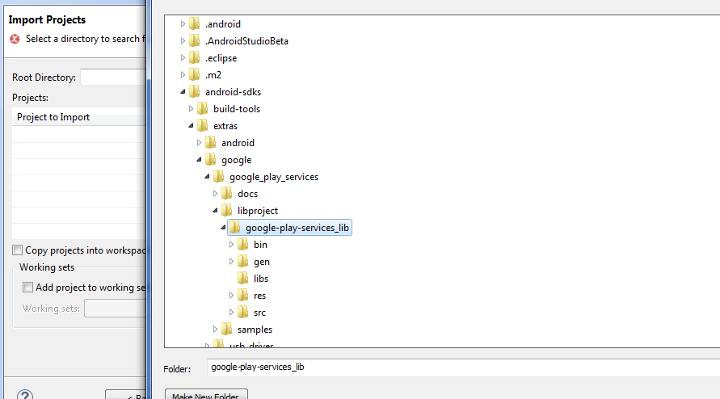

1. **Configure the building path**

* There is one special External Jar that you have to add it into your building path manually. Open the Dependencies Folder, you can find the “Lombok Jar”.

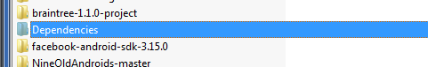

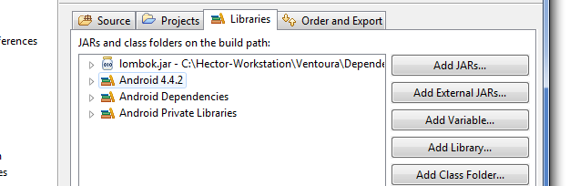

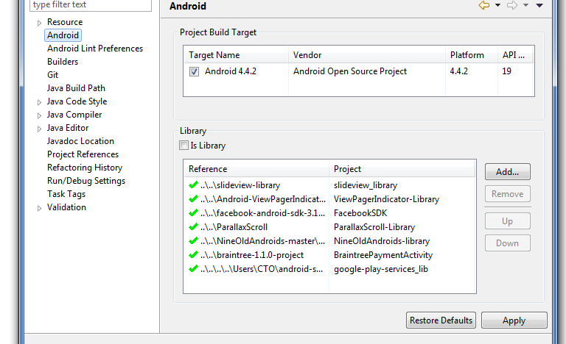

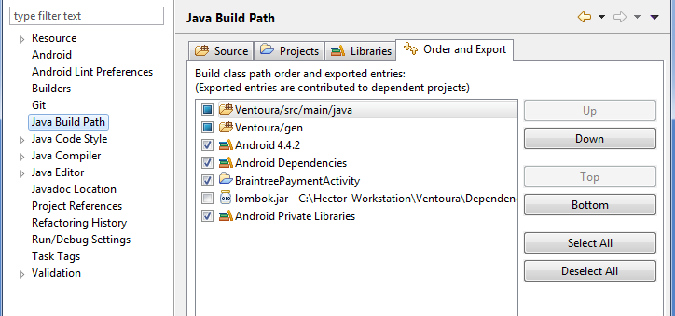

**Don’t tick the Lombok.jar**

1. **Running Ventoura**

If there is no building path errors, you can try to run the ventoura in your own phone.

1. **Configure Git**

Once you have a bitbucket account, please let me know. I will add you into our ventoura developing team.

1. **Facebook Configuration**

* I send you invitation to be a developer in facebook. You need to confirm it. Once you done this.
* If you cannot login to Ventoura because of invalid hashcode error. Let me know.